<https://dlussocollection.com/>

Backlink Analysis Dated : 18/03/2020

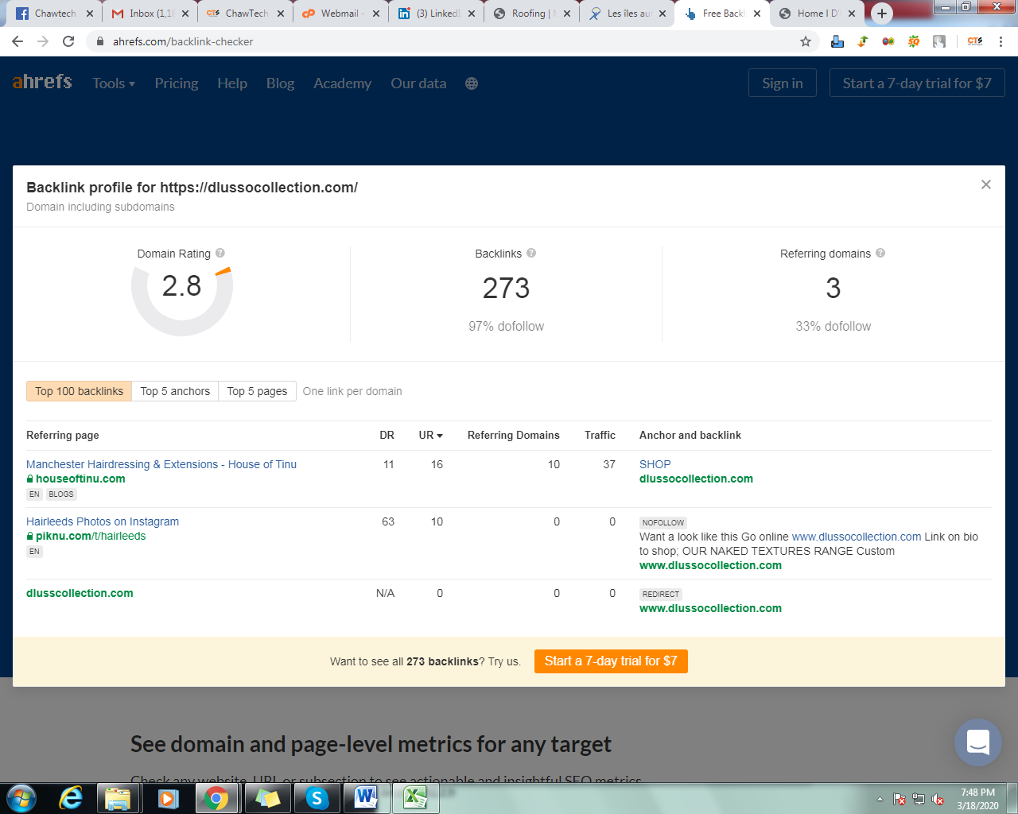

Backlink : only 273

Referring domain: only 3

Can I get some offer related to all product something like below:

Buy Beauty Forever Top Quality Brazilian Hair,Brazilian Weave, Virgin Brazilian Hair, Brazilian Hair Bundles,Wholesale Virgin Remy Brazilian Human Hair 8-30 Inches, Brazilian Curly Hair, best Brazilian hair extensions with very affordable price.

Beautyforever Hai Curly Lace Closure , Curly Hair Closure , Brazilian Curly Lace Closure, Curly Hair with Closure,100% human hair, package the postage and no tax, support return and change product within 7 days.

Living your best life.Lets make your Wig life dream come true with Dlusso collection ! If you have a question before booking your appointment, please contact our salon directly on 01612728725.check out here <https://dlussocollection.com/>

Dlussocollection hair curly lace, ***lace wigs real virgin hair, hair piece, virgin hair, Russian hair, Brazilian hair, clip in extension***

Beautyforever Mall provide 100% Remy hair, I Tip Hair Extensions,I Tip Human Hair Extensions, I-Tip Hair Extensions,Remy hair extensions,100% human hair, package the postage and no tax, return and change product within 7 days

Shop Beautyforever Body Wave Wig in best quality, top-selling Body Wave Lace Front Wig, Body Wave Human Hair Wigs, Brazilian Body Wave Wig Human Hair for fashion women to get attractive and fabulous wavy hair.

Beautyforever wholesale best 613 Blonde Wig for beautiful hairstyles. Different lace design Blonde lace front, full lace, 360 lace wigs, and different hair length short blonde wig and long blonde wig are available for fashion women **attractive locks.**

4 different unprocessed body wave human hair: Brazilian Body Wave Hair, Peruvian body wave, Malaysian body wave, Indian body wave hair 1 bundle, 3 bundles, 4 bundle deals for American Women. Best quality body wave hair weave, body wave bundles virgin hair, Available in lengths from 8" to 30".